Vehicle Management

Project

**TEAM MEMBERS**

**GANESH PANDIYAN**

**PRATHIPARAJ**

**MATHAVAN**

**RANJITH KUMAR**

**INTRODUCTION**

Are you new to Salesforce? Not sure exactly what it is, or how to use it? Don’t know where you should start on your learning journey? If you’ve answered yes to any of these questions, then you’re in the right place. This module is for you.

Welcome to Salesforce! Salesforce is game-changing technology, with a host of

productivity-boosting features, that will help you sell smarter and faster. As you work toward your badge for this module, we’ll take you through these features and answer the question, “What is Salesforce, anyway?”

**OBJECT**

### **To Create An Object**

For this Vehicle Management we need to create three custom objects i.e. Vehicles, Driver and Traveler.

The below steps will assist you in creating those objects.

* Click on the gear icon and then select Setup.
* Click on the object manager tab just beside the home tab.
* After the above steps, have a look on the extreme right you will find a Create Dropdown click on that and select Custom Object.

On the Custom Object Definition page, create the object as follows:

* Label: Vehicle
* Plural Label: Vehicles
* Record Name: Vehicle Name
* Check the Allow Reports checkbox
* Check the Allow Search checkbox
* Click Save.
* Now create a custom tab. Click the Home tab, enter Tabs in Quick Find and select Tabs.
* Under Custom Object Tabs, click New.
* For Object, select Vehicle.
* For Tab Style, select any icon.
* Leave all defaults as is. Click Next, Next, and Save.

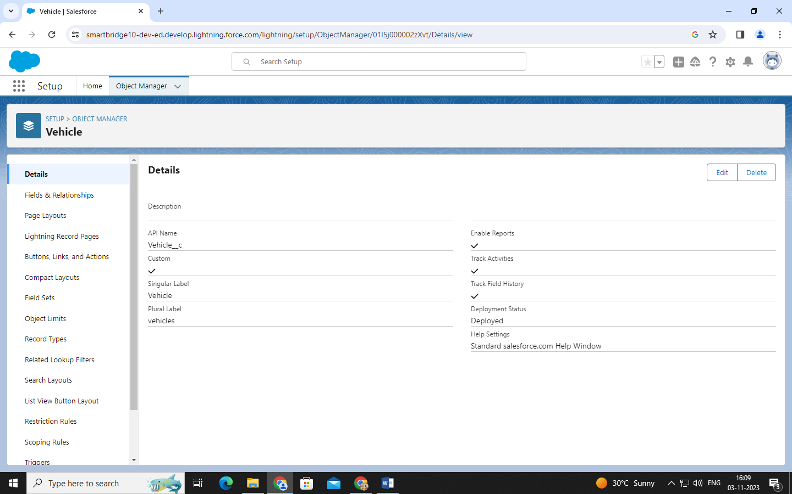

### **To Create The Driver Object**

For this Vehicle Management we need to create three custom objects i.e. Vehicles, Driver and Traveler.

The below steps will assist you in creating those objects.

* Click on the gear icon and then select Setup.
* Click on the object manager tab just beside the home tab.
* After the above steps, have a look on the extreme right you will find a Create Dropdown click on that and select Custom Object.

On the Custom Object Definition page, create the object as follows:

* Label: Driver
* Plural Label: Drivers
* Record Name: Driver Name
* Check the Allow Reports checkbox
* Check the Allow Search checkbox
* Click Save.
* Now create a custom tab. Click the Home tab, enter Tabs in Quick Find and select Tabs.
* Under Custom Object Tabs, click New.
* For Object, select Driver.
* For Tab Style, select any icon.
* Leave all defaults as is. Click Next, Next, and Save.

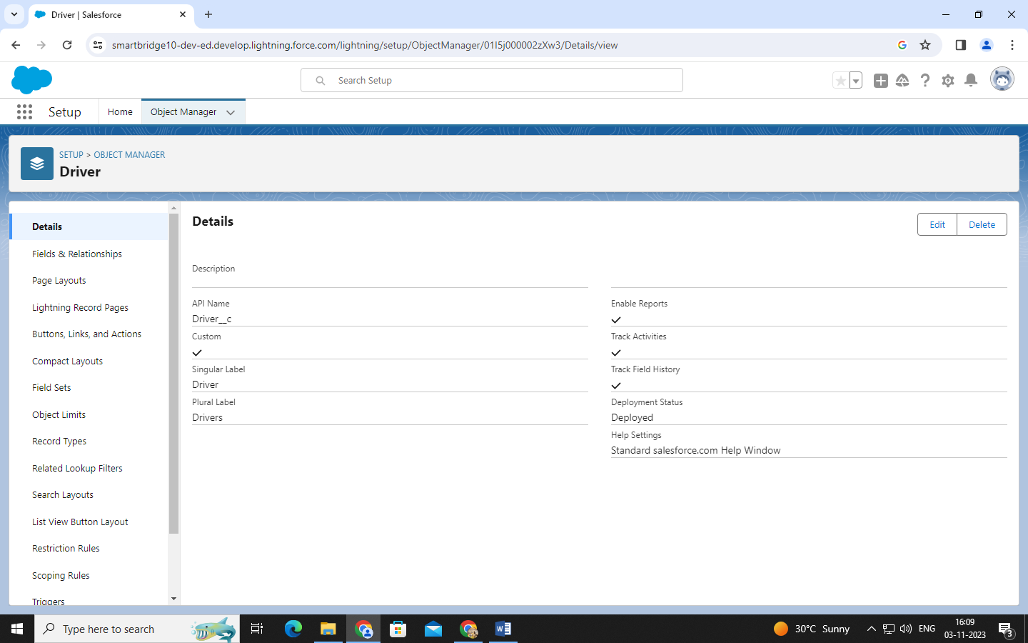

### **To Create The Traveler Object**

For this Vehicle Management we need to create three custom objects i.e. Vehicles, Driver and Traveler.

The below steps will assist you in creating those objects.

* Click on the gear icon and then select Setup.
* Click on the object manager tab just beside the home tab.
* After the above steps, have a look on the extreme right you will find a Create Dropdown click on that and select Custom Object.

On the Custom Object Definition page, create the object as follows:

* Label: Traveler
* Plural Label: Travelers
* Record Name: Traveler Name
* Check the Allow Reports checkbox
* Check the Allow Search checkbox
* Click Save.
* Now create a custom tab. Click the Home tab, enter Tabs in Quick Find and select Tabs.
* Under Custom Object Tabs, click New.
* For Object, select Traveler.
* For Tab Style, select any icon.
* Leave all defaults as is. Click Next, Next, and Save.

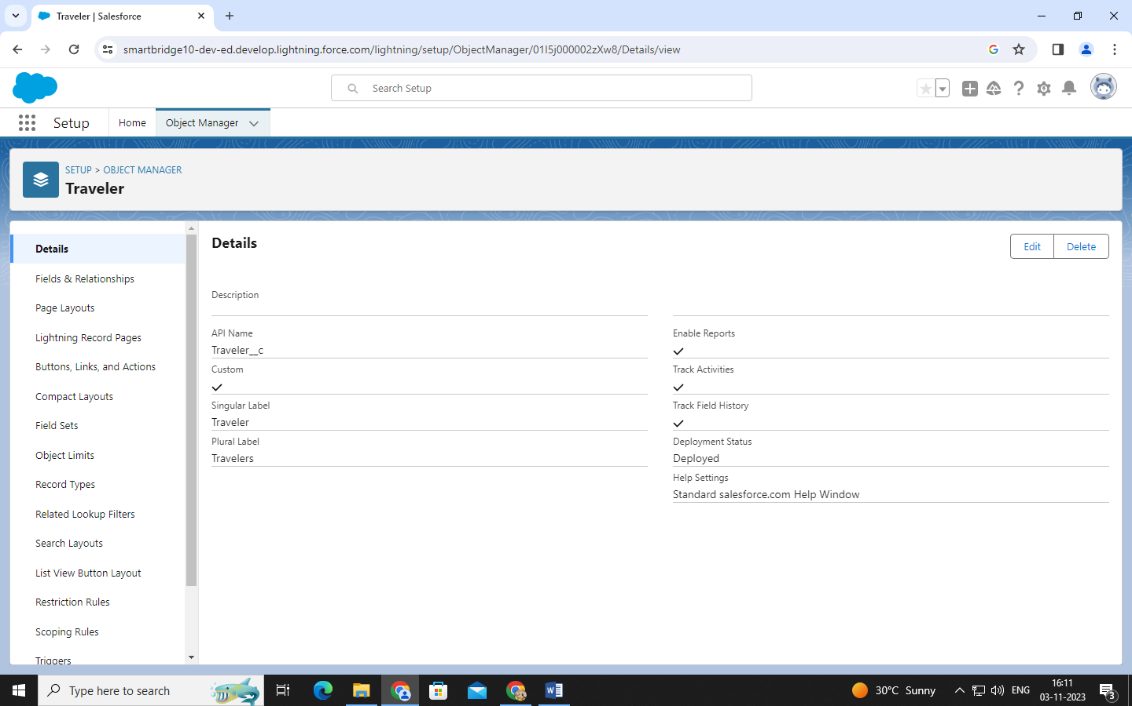

**FIELD&RELATIONSHIP**

### **Creation Of Fields**

1.Click on the gear icon and then select Setup.

2.Click on the object manager tab just beside the home tab.

3.Search object (Vehicle) in quick find box.

4.Click fields & relationships and click new

5.Select any data type click next

6.Enter field label name and select next, next, and Save.

### **Fields In Vehicle Object**

Create a dependency between these two picklists, so that when a Vehicle type is selected,

only respective 2Wheeler Brands are available in the 2Wheeler field, similarly for4Wheelers.

The below steps will assist you in creating Field Dependencies.

1. Click on the gear icon and then select Setup.
2. Click on the object manager tab just beside the home tab.
3. After the above steps, Select Vehicles Object
4. Now Select Fields and relationships from setup menu of the vehicle object.
5. Click Field Dependencies.
6. Click New.
7. Select Vehicle Type as the Controlling Field and select 2wheelers as the Dependent Field.
8. Click Continue.
9. Select the appropriate 2 wheelers Brands in each column by double-clicking them.

2 WHEELERS :

i) HERO

ii)HONDA

iii)BAJAJ

iv)ROYAL ENFIELD

v)  TVS

vi)KINETIC

vii)OLA

viii)JAWA

ix)SD

x)BATTERY

1. Click Include Values.
2. Click Preview, then test the dependency by selecting different Vehicle Type and viewing the different Vehicles available     for Vehicle Type.
3. Click Close to close the preview window.
4. Click Save.

Follow same steps for 4wheelers also

1.Vehicle Type as the Controlling Field and select 4wheelers as the Dependent Field.

2.Click Continue.

3.Select the appropriate 4wheelers Brands in each column by double-clicking them.

4.4WHEELERS :

i)RENAULT

ii)SKODA

iii)HONDA

iv)HYUNDAI

v)SUZUKI

vi)MAHINDRA

vii)VOLKSWAGEN

viii)BENZ

ix)AUDI

x)VOLVO

5.Click Include Values.

6.Click Preview, then test the dependency by selecting different Vehicle Type and viewing the different Vehicles     available for Vehicle Type.

7.Click Close to close the preview window.

8.Click Save.

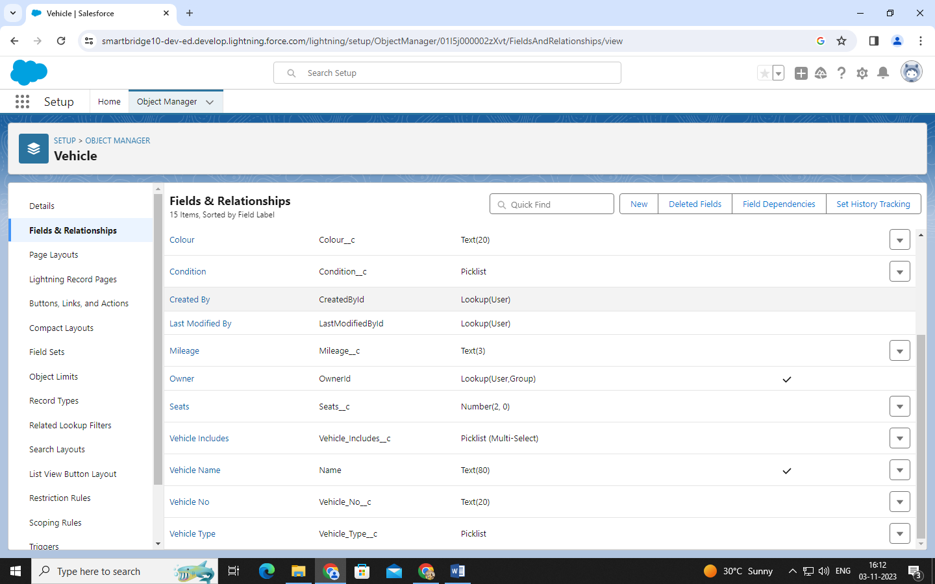

### **Fields In Driver Objects Follow Below Data Types:**

Create a Lookup fields

* Click fields & relationships and click new
* Select Lookup relationship & click next
* Choose the related object as Vehicle & click next
* Give the field label & click next, next, next and Save.

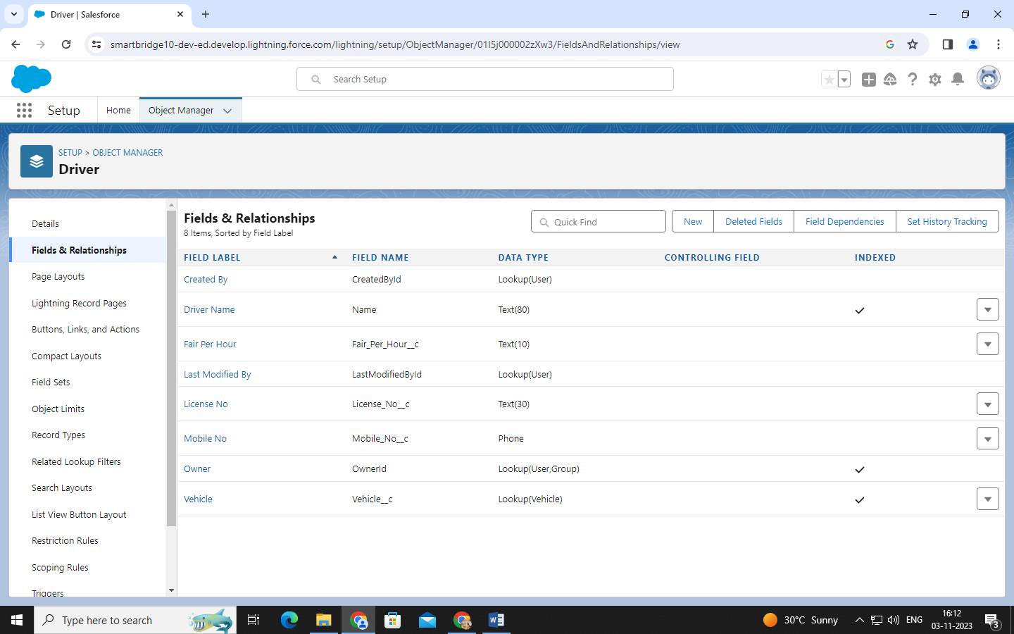

### **Fields In Traveler Objects Follow Below Data Types**

|  |  |  |  |
| --- | --- | --- | --- |
| **S No** | **Field** | **Type** | **Data Type** |
| 1 | Traveler Name | Standard | Text |
| 2 | Traveler Contact No | Custom | Phone |
| 3. | Traveler Email | Custom | Email |

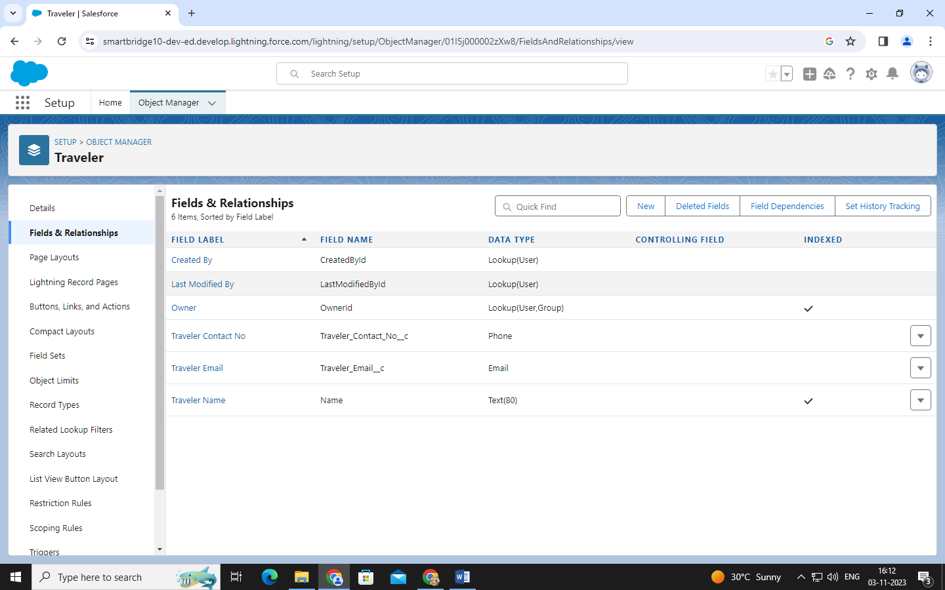

### **Fields In Opportunity Objects Follow Below Data Types**

|  |  |  |  |
| --- | --- | --- | --- |
| **S No** | **Field** | **Type** | **Data Type** |
| 1 | Vehicle | Custom | Lookup (Vehicle) |
| 2 | Journey Start Date | Custom | Date/Time |
| 3 | Journey End Date | Custom | Date/Time |
| 4 | Total Fair | Custom | Currency (8) |
| 5 | Route | Custom | Text(long) |

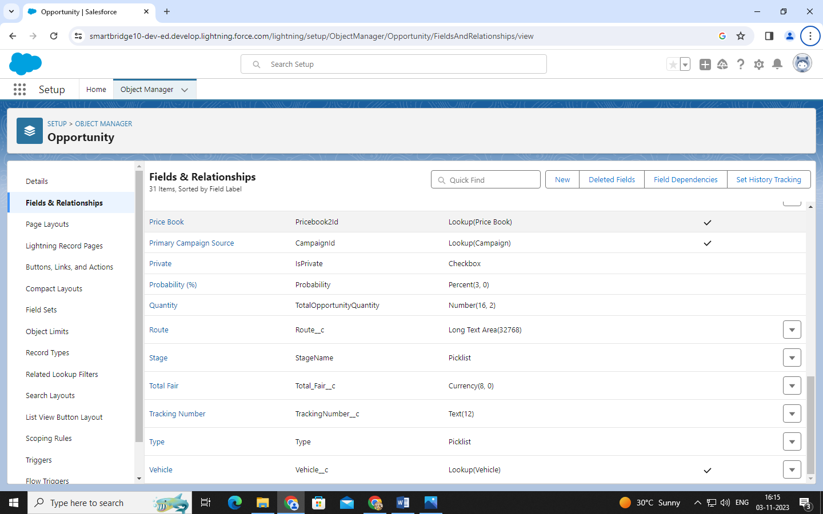

**PAGE LAYOUT SETUP**

### **Organize Opportunity Layout**

Organize Opportunity layout

* Click on the gear icon and then select Setup.
* Click on the object manager tab just beside the home tab.
* Search in quick find (Opportunity) & select Opportunity.
* Click on page layout and you can add or remove fields by drag & drop

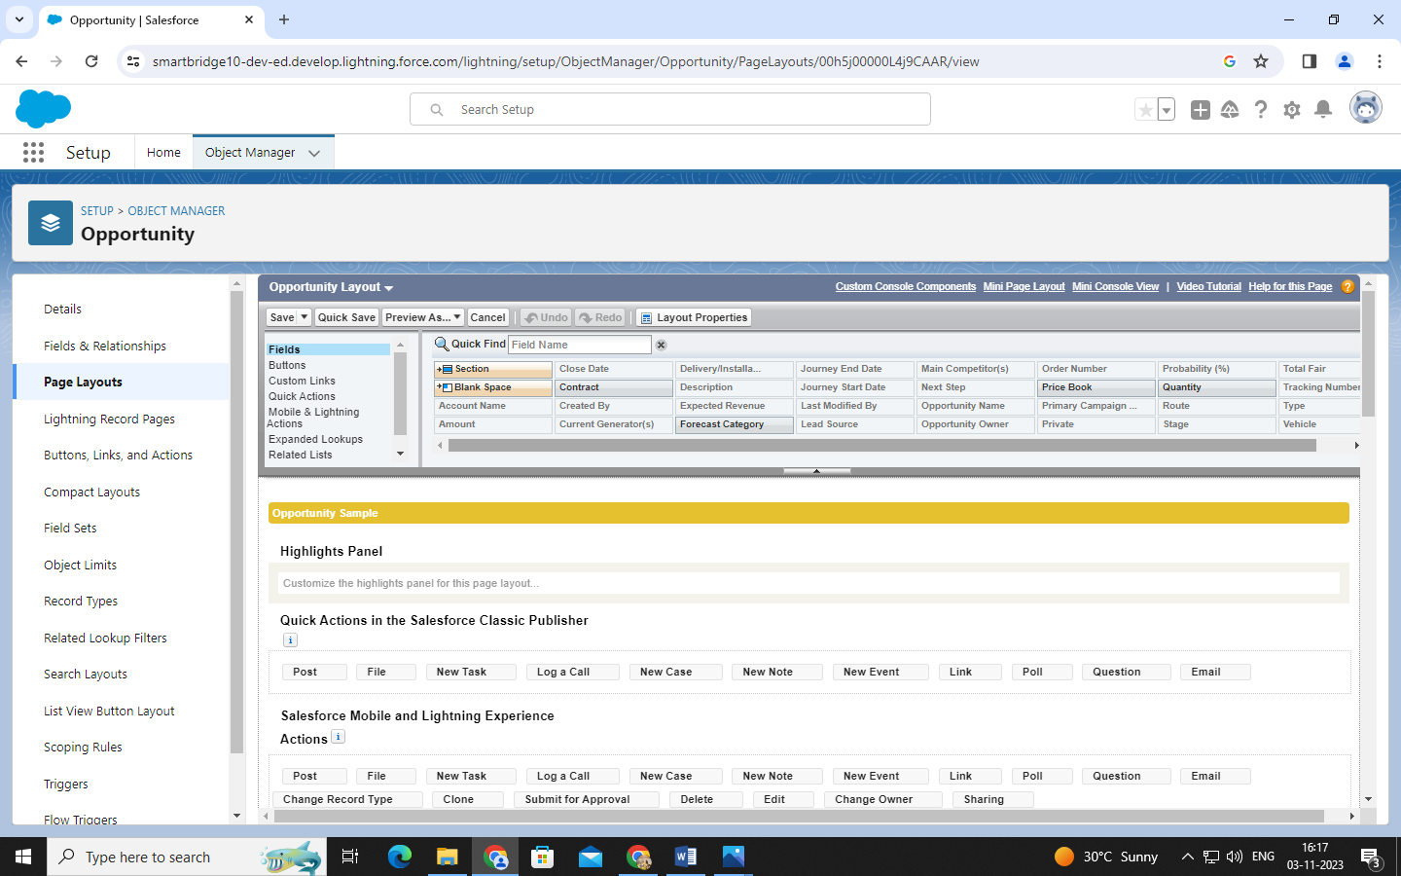

LIGHTNING APP

### Create The Vehicle Management App

* From Setup, enter App Manager in the Quick Find and select App Manager.
* Click New Lightning App. Enter Vehicle Management as the App Name, then click Next
* Under App Options, leave the default selections and click Next.
* Under Utility Items, leave as is and click Next.
* From Available Items, select Accounts, Contacts, Opportunities, Vehicle, Driver, Travelers, Reports, and Dashboards and move them to Selected Items. Click Next.
* From Available Profiles, select System Administrator and move it to Selected Profiles. Click Save & Finish.
* To verify your changes, click the App Launcher, type Vehicle Management and select the Vehicle Management app.

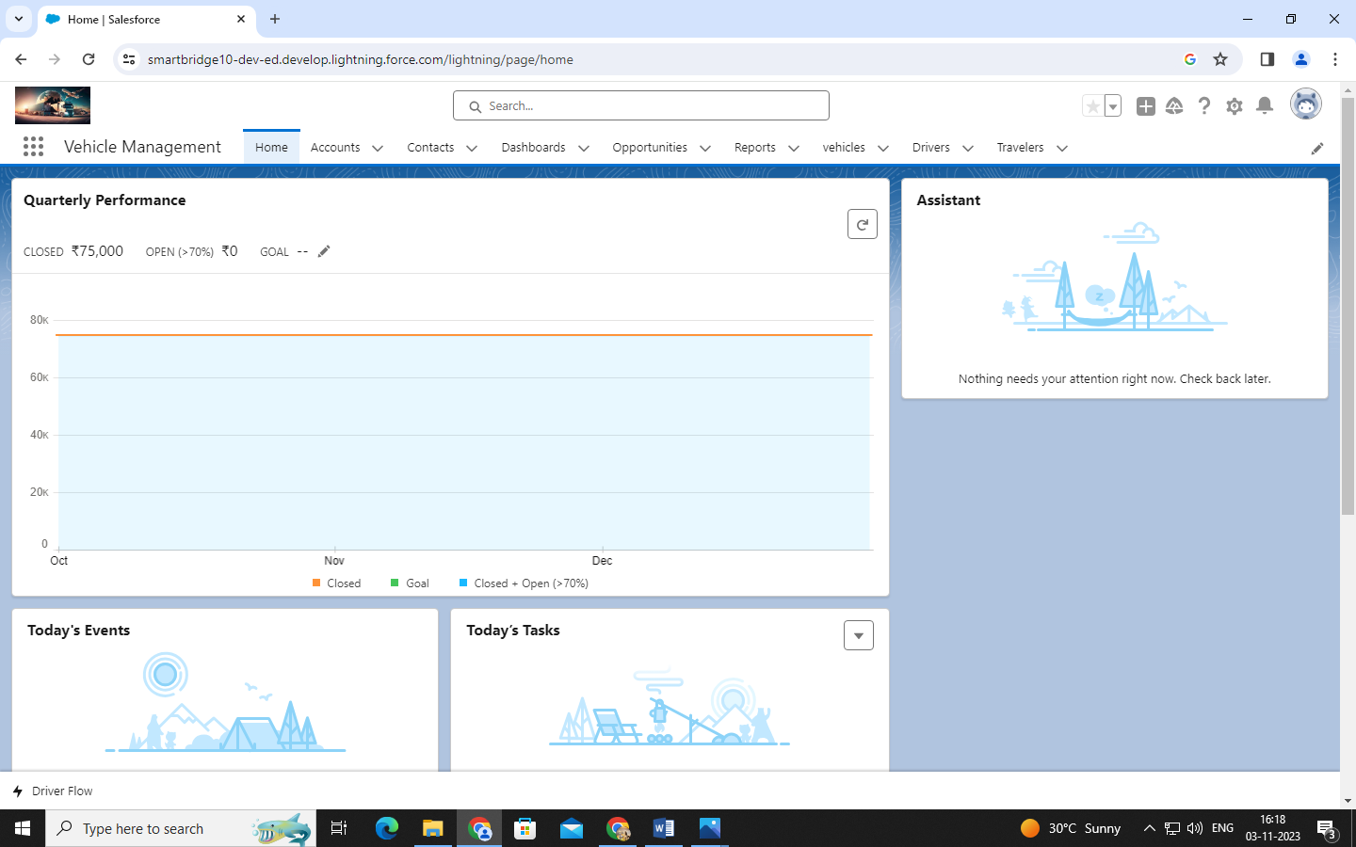

PROFILE

### **Creating A Profile**

Now create a Vehicle Manager profile and set its object permissions.

* From Setup enter Profiles in the Quick Find box, and select Profiles.
* From the list of profiles, find Standard User.
* Click Clone.
* For Profile Name, enter Vehicle Manager.
* Click Save.
* While still on the Vehicle Manager Profile page, then click Edit.
* Scroll down to Custom Object Permissions and give access for Create, Read, Edit, and Delete, View all and modify all for Vehicle object Driver object and Traveler object

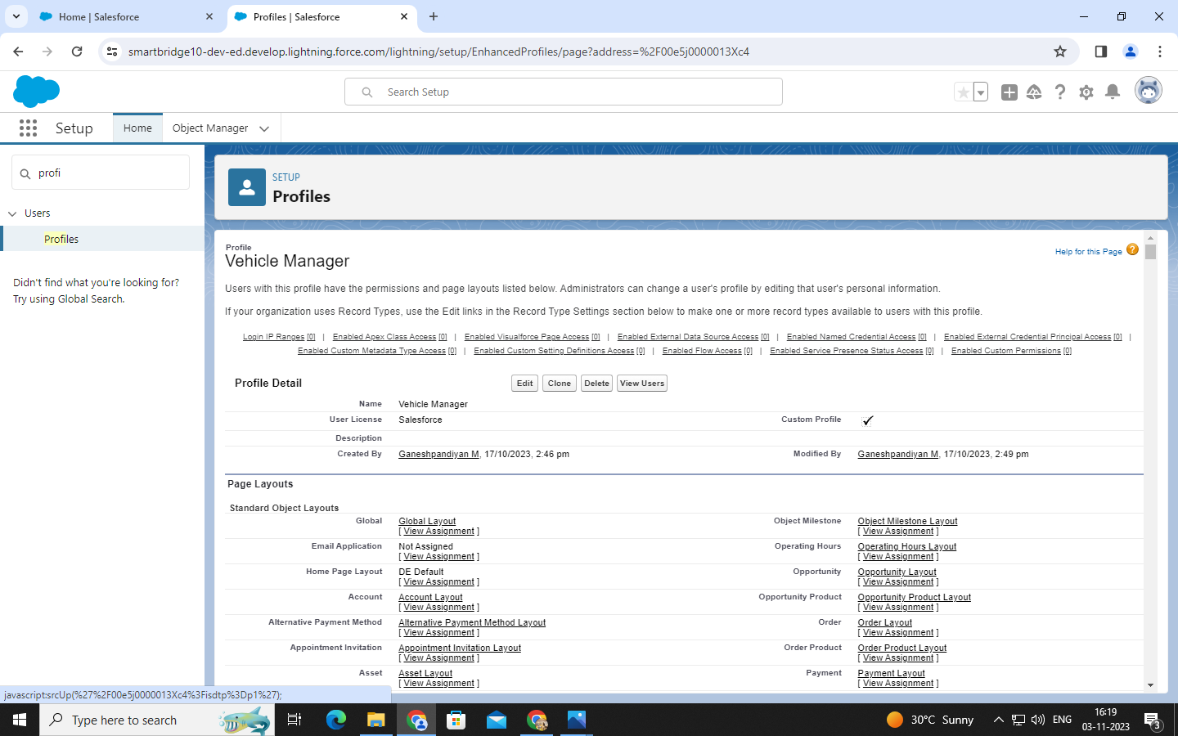

### **Setup Roles**

1.Click on the Gear Icon

2.Click "Setup"

3.In the Quick Find box, enter "Roles"

4.Click "Roles"

5.Click on "Set Up Roles"

6.Click "Expand All"

7.Under the CEO, click on "Add Role"

8.Fill up the Label as Vehicle Manager, Role Name Vehicle Manager.

9.Enter a Role name that will be displayed on Reports

10.Click on Save.

Similarly create Two Roles under Vehicle Manager as Operator 1 And Operator 2 Roles which will report to the Vehicle manager.

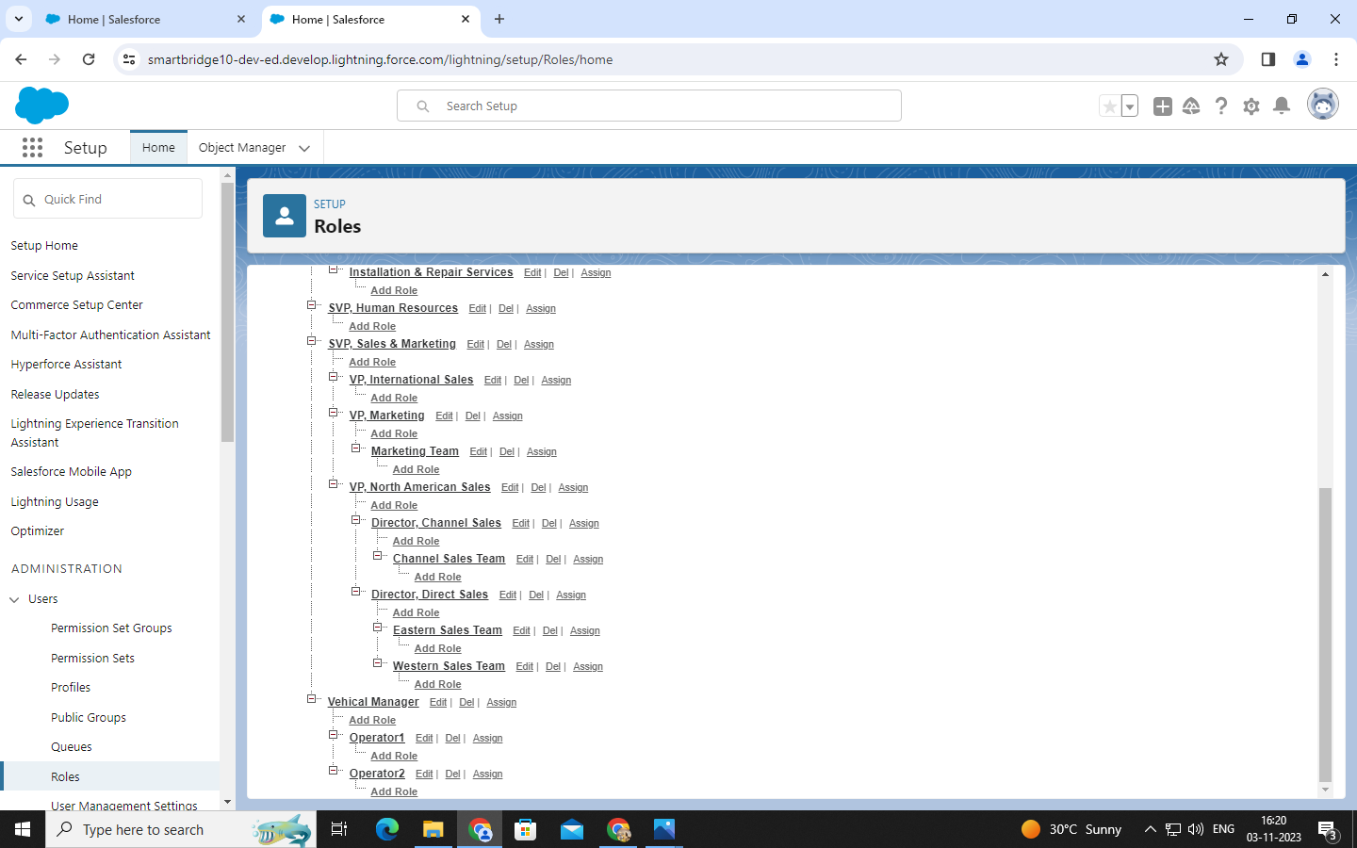

USERS

### **Creating A User**

1. From Setup, in the Quick Find box, enter Users, and then select Users.
2. Click New User.
3. Enter the user’s name John Teddy and (Your) email address and a unique username in the form of an email address. By default, the username is the same as the email address.
4. Select a Role(Vehicle Manager)
5. Select a User License As salesforce.
6. Select a profile as Vehicle Manager.

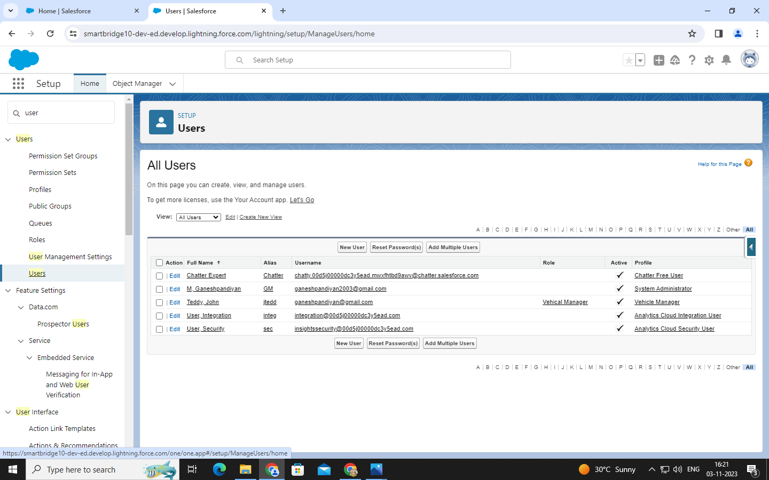

USER ADOPTION

### **Create Vehicle Record**

* Click on App Launcher on left side of screen.
* Search Vehicle Management System & click on it.
* Click on Vehicle tab.
* Click new button
* Fill all Vehicle record details.
* Click on Save Button

### **View Record**

View Record (Vehicle):

* Click on App Launcher on left side of screen.
* Search Vehicle Management System & click on it.
* Click on Vehicle Tab.
* Click on any record name. you can see the details of the Vehicle

### **Delete Record**

Delete Record (Vehicle):

* Click on App Launcher on left side of screen.
* Search Vehicle Management System & click on it.
* Click on Vehicle Tab.
* Click on Arrow at right hand side on that Particular record.
* Click delete and delete again.

REPORT & APPROVAL

### **Create Report**

1.Go to Reports and click NewReport.

2.Select the opportunities report type and click Start Report.

3.Click on add columns, addOpportunity Owner,Opportunity Name and remove all others

4.Add Group Rows Select Journey,Start Date,Journey End Date.

5.Click Save.

6.Click on Report drop down and

Select Joined Report ,click on apply

7.Click on Add Block

8.Select All From Category And

Select Customer Details then Click on Add Block.

9. Add opportunity Owner in Group

Across Blocks

10.Save your report as

Opportunities Details And Select Private report.

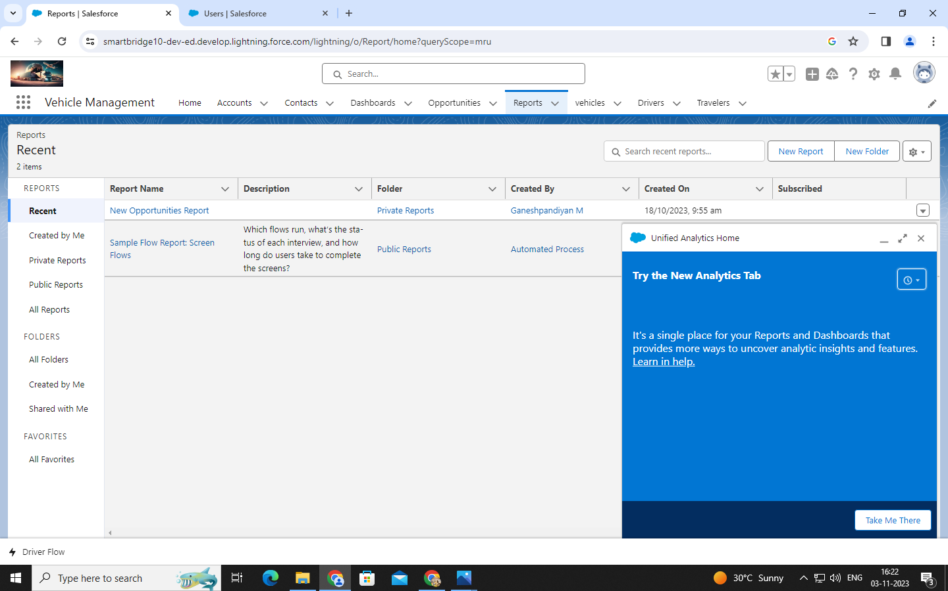

### **Create Dashboard**

1. Click the Dashboards tab.
2. Click New Dashboard.
3. Name the dashboard Opportunity Details and click Create.
4. Click +Component.
5. Select the Opportunity Details and click Select.
6. Select the Vertical Bar Chart component and click Add.
7. Click Save and then Done.

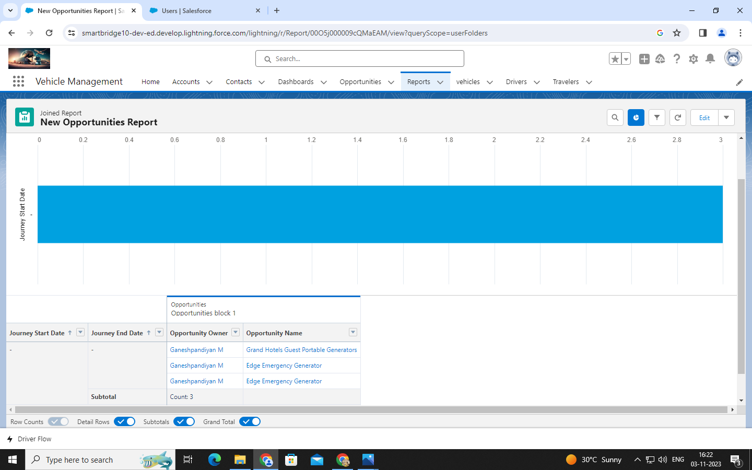

APPROVAL PROCESS

### **Creation Of Approval Process**

Click Setup and select Setup.

1. Select Process Automation | Approval Processes (or use the Quick Find and search for Approval Processes)
2. In the Manage Approval Processes For list, select Driver.
3. Click Create New Approval Process and select Use Jump Start Wizard.
4. Enter the following parameters

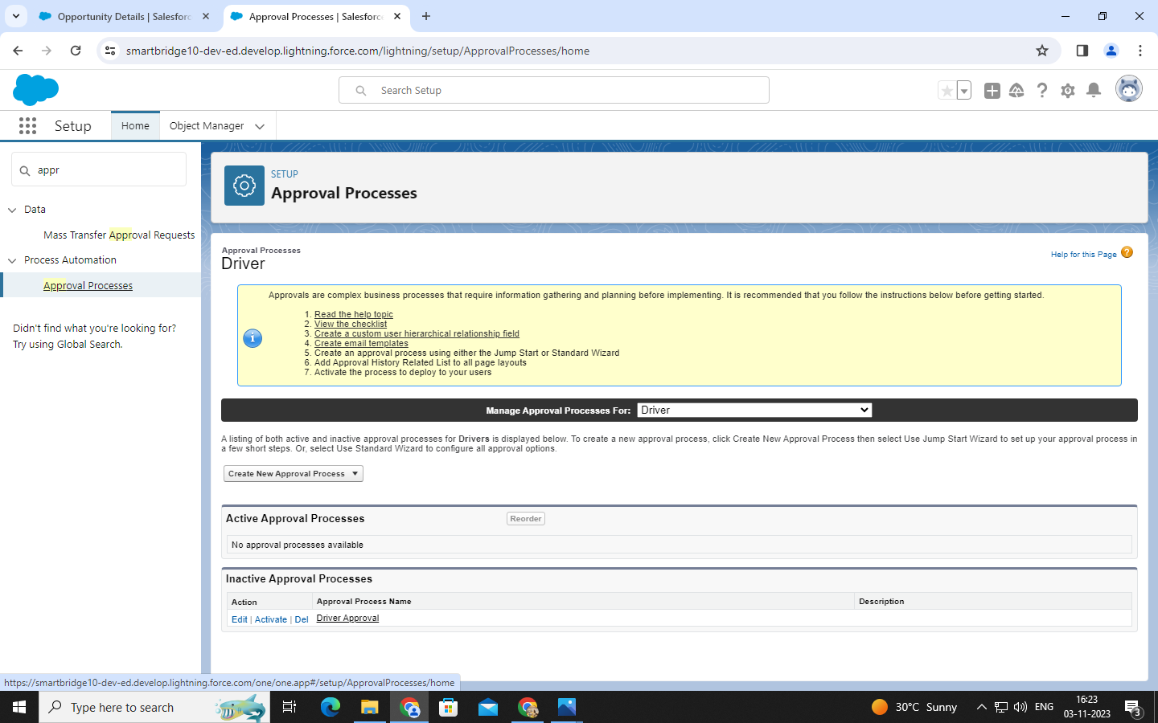

SCREEN FLOW

In Salesforce, flows are visual representations of business processes that can be created and managed using the Salesforce Flow Builder. Flows are designed to automate and streamline complex business processes, such as collecting data, updating records, and integrating with external systems, without writing any code.

Screen Flows: Screen flows are flows that are designed to guide users through a series of screens to collect data or present information. They are typically used to create user-friendly data entry forms or wizards, and can include input fields, picklists, and other user interface components.

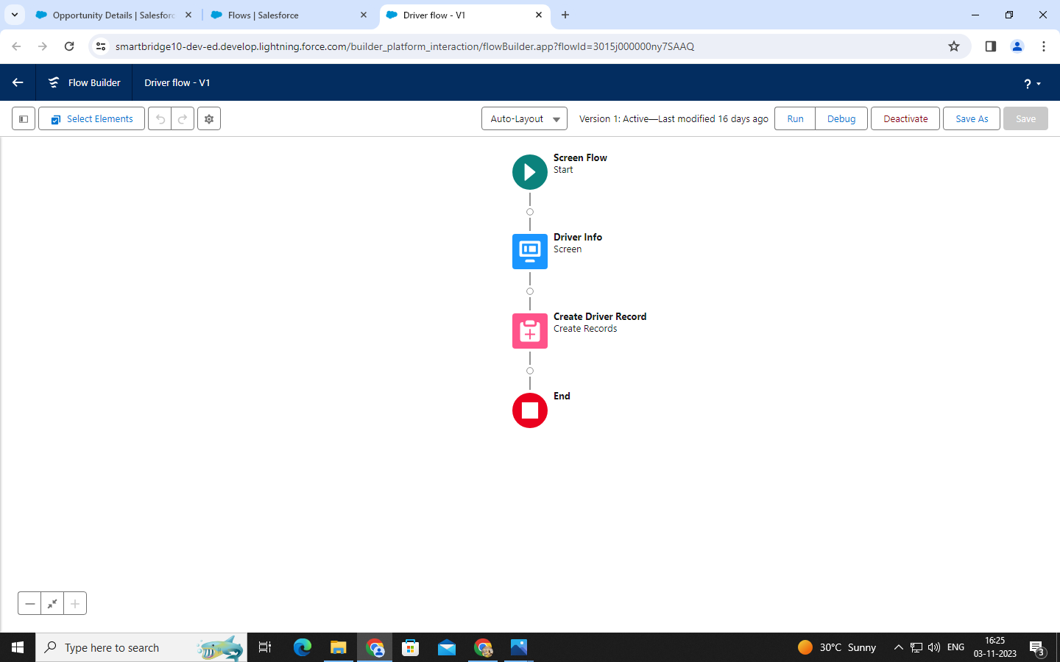

APP PAGE

App page descriptions in Salesforce refer to the metadata and configuration settings that define the visual layout, functionality, and behaviour of custom app pages within a Salesforce org. App pages are created using the Salesforce App Builder, which is a visual drag-and-drop tool that allows users to create custom pages without writing code.

